***Caremed M34 Air Pump***

***For Air Transfer Mat***

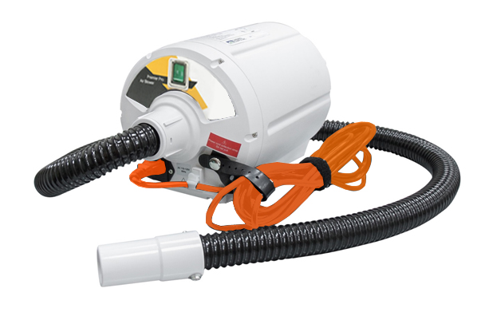

**USER MANUAL**

**Contents**

|  |  |
| --- | --- |
| Purpose of this Manual........................................................................................ | 1 |
| Product Description – Intended Use........................................................................... | 1 |
| General safety..................................................................................................... | 1 |
| Device Feature and Instruction for Use............................................................... | 2-4 |
| Maintenance & Troubleshooting.......................................................................... | 5 |
| Cleaning & Disinfectiion Protocol........................................................................ | 6 |
| Specification Chart.......................................................................................................... | 7 |
| Electromagnetic Compatibility............................................................................... | 8 |
| Waste Disposal.................................................................................................... | 9 |
| Storage and Care................................................................................................. | 9 |
| Symbols Used....................................................................................................... | 9 |
| Expected Service Life........................................................................................... | 10 |
| Warranty................................................................................................................  Part Replacement.................................................................................................. | 10  11-12 |
|  |  |
|  |  |

1. **Purpose of this Manual**

This operation manual is mainly focused on the set-up, cleaning and routine maintenance of **Caremed M34 Air Pump**. We recommend keeping this manual handy to answer most of the question related to the system.

1. **Product Description –** **Intended Use**

**Caremed M34 Air Pump** is an air supply unit for air-assisted lateral transfer system designed to help clinicians safely move patients. The system has been designed to reduce risks and make patient transfers easier and safer. It also allows the patient to conveniently remain on the transfer pad for ancillary procedures.

1. **General Safety**

**Precaution – About Air Transfer Mat:**

1. Use two or more caregivers during patient transfer.
2. Do not use the transfer mat until the user manual is reviewed.
3. Do not leave patient unattended on inflated transfer mat.

It is important to read the information in this user manual before you use **Caremed M34 Air Pump**.

Please follow the guidelines below for your added safety and maintaining system performance.

* Use this product only for its intended use as described in this manual. Do not use attachments not recommended by the manufacturer.
* Maximum patient weight is 450 kg (1,000 lbs.).
* Avoid exposing the Air Pump unit to flammable anesthetics.
* The air blower needs to be used with a stable power supply or in connection with a UPS.

1. **Device Features**

***Part Introduction*:**

**4-1. Front view**

Power switch

Caution sticker

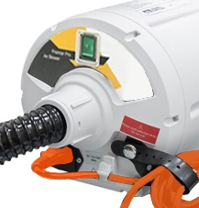

Power cord collection strap

Air Hose

Power cord

Power cord fixer

**4-2. Back view**

Handle/Hanging hook

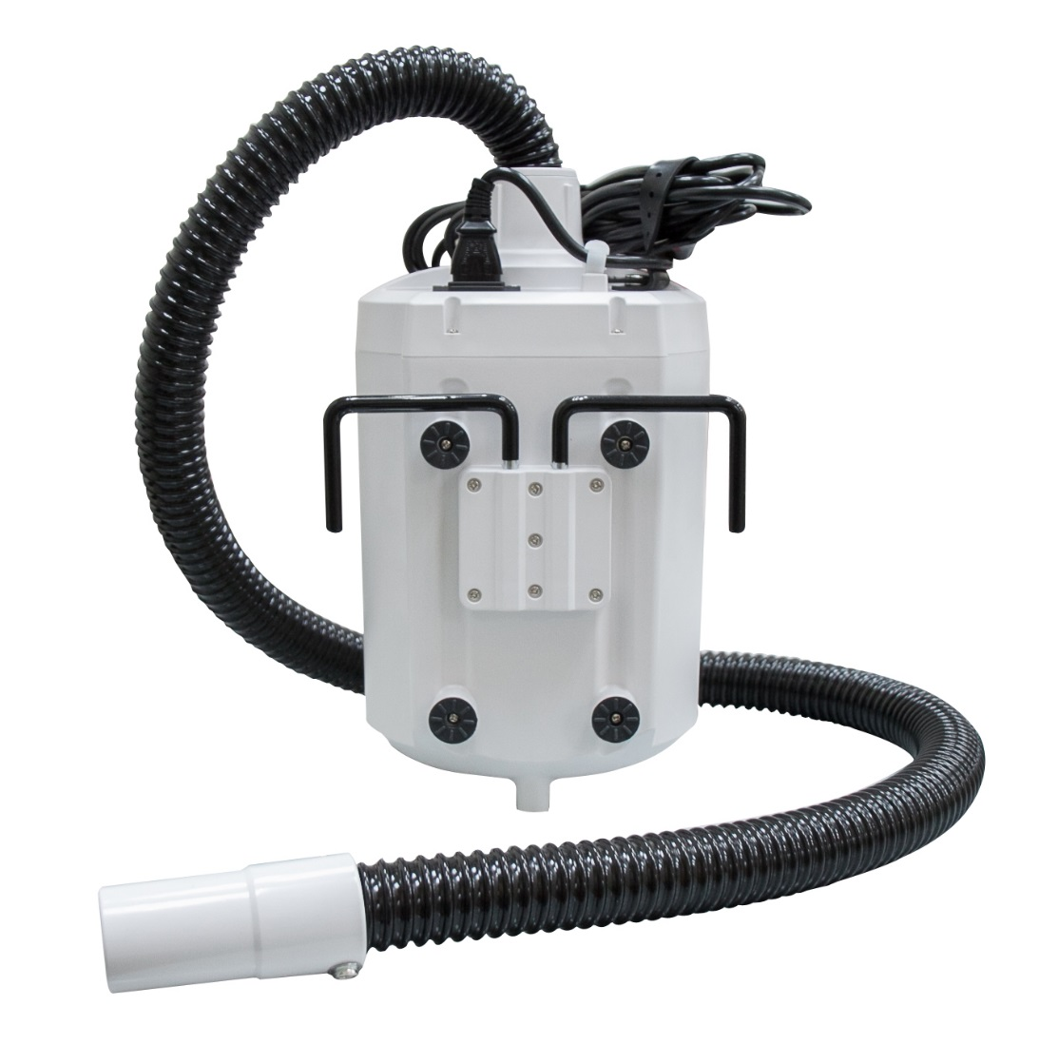

Rubber Foot Pad

Air hose

1. cid:image004.jpg@01D30704.B4AE45E0 **Instruction for use of Caremed M34 Air Pump**

Press the power switch on the front panel to start and turn off the Air Pump.

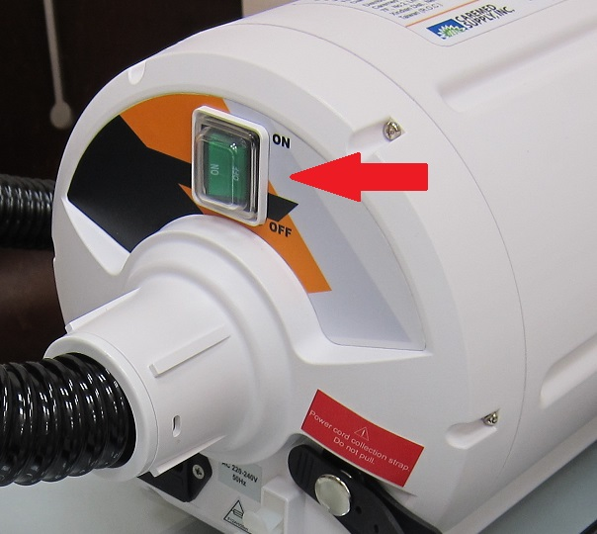

1. cid:image004.jpg@01D30704.B4AE45E0**Instruction for use of Air Transfer Mat**
2. Transfer surface should be close together and equal high or a slightly lower destination surface.
3. Air inlet pockets are located at the foot end of the pad. Locate and insert air supply hose.
4. Avoid having obstructions in path of transfer, including lines and hoses.
5. Hold unto handle during inflation.
6. Move patient in a diagonal direction, head or feet end first, until patient reaches destination and is centered.
7. Raise side rails, disconnect air hose and undo safety straps.
8. Use appropriate turning and rolling technique to remove transfer mat from underneath patient.



**CCAUTION: Be sure to routinely check power cable to ensure it’s not obstructed or causing a tripping hazard. Check the power cable is not under strain or damaged.**

**CAUTION: Never leave your patient unattended with Caremed M34 Air Supply Unit on.**

1. **Maintenance & Troubleshooting**

No daily maintenance is required. It is intended this equipment should only be serviced by qualified and authorized technical personnel.

|  |  |  |
| --- | --- | --- |
| **Fault/Problem Description** | **Possible Root Cause** | **Solution** |
| The Air Pump will not turn on | The Air Blower Unit is not receiving the power. | * Check power cord plug is securely connected and fits snugly into the outlet. Secure plug connection and turn on power. * Check electrical outlet for proper ground. |
| Blown fuses in pump and plug. | * Check for blown fuses in pump and plug. Replace fuses if blown. |
| Mains socket is faulty. | * Try another socket. |
| Defective Air Pump unit. | * Replace with new device. |
| The Air Transfer Mat cannot inflate | Air Flow is not sufficient. | * Check hose connection points and re-connect it properly. * Check hose for tears or kinking. * Check stitched seams for failure. * Check for punctures or rips on Air Transfer Mat surfaces. * Check the air filter for restrictions. Clean/replace as necessary. |

**Warning:** Disassembly or attempts to make repairs may void Manufacturer’s Warranty. Please consult the Statement of Warranty of this Manual for more information.

If the problem is not resolved, please contact professional personnel for advice.

1. **Cleaning & Disinfection Protocol**

It is very important to have a strict cross infection, cleaning and disinfection policy in line with current Hospital/Nursing Home infection control guidelines.

1. Switch off the electrical supply to the pump and disconnect the power cord from the main supply before cleaning and inspection.
2. Do not use the phenol based cleaning solutions.
3. The casing of the air pump is made of ABS plastic which is combination of different resins that is hard and durable through a broad range of temperature. If soiled, it can be wiped down with a sodium hypochlorite solution to dilution of 1000ppm a damp or with any EPA approved, hospital grade cleaner.

**WARNING!!!**

* **Switch off the electrical supply to the pump and disconnect the power cable from the mains before cleaning and inspection.**

All equipment should be inspected. Any item that is visibly soiled with the patient’s blood or other body fluids should be properly cleaned or removed. It is recommended that the system is clean regularly and after each patient use.

**9. Specification**

**Control unit Specification**

|  |  |
| --- | --- |
| Model Name: | **Caremed M34 Air Pump** |
| Size in CM (L x W x H): | 32.5 X 19 X 20.5 |
| Weight: | 6 kgs |
| Air Hose | 37mm dia x 1.5m length |
| Flow Rate | **≧**2,500 L/min |
| Rated Voltage: | AC220 - 240V /50Hz |
| Max Current: | 10A |
| Fuse rating: | F12AH 250V |
| Classification | Class II, Type BF |
| Environment (Temperature) | Operation: 15o C to 35o C (59o F to 95o F) |
| Storage:5 o C to 60 o C (41o F to 140o F) |
| Environment (Humidity) | Operation: 30% to 75% non-condensing |
| Storage: 30% to 75% non-condensing |
| Filter Air | 5 microns |
| Test Standard: | IEC60601-1, IEC60601-1-2 |

**Warning:** Medical electrical equipment needs special precautions regarding EMC and needs to be installed according to the EMC information provided. Careful consideration of this information is essential when stacking or collocating equipment and when routing cables and accessories.

**Warning:** RF mobile communication equipment could interfere with medical electrical equipment.

**10.ELECTROMAGNETIC COMPATIBILITY**

Electrical devices may interact due to electro-magnetic radiation. We recommend a safety distance of at least 1-metre especially for sensitive equipment.

Upon request, we will provide you with a table for more detailed information.

EMC chart to be added.

**11. Waste Disposal**

This Product has been supplied from an environmentally aware manufacturer that complies with the WEEE.

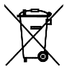

This product may contain substances that could be harmful to the environment if disposed of in places (landfills) that are not appropriate according the legislation. Please be environmentally responsible and recycle this product through your recycling facility at its end of life.

**12. Storage and Care**

**Caremed M34 Air Pump:**

* Check the power cord and plug for abrasions or excessive wear.
* Plug in the unit and verify air flows from the units hose connection ports
* Place in box for storage

It is recommended the following guidelines are used whenever this system is stored or transported to another location:

Temperature limitations: 5 o C to 60 o C (41o F to 140o F)

Relative Humidity: 30% ~90%

**13. Symbols List**

|  |  |  |  |
| --- | --- | --- | --- |
| 「type bf applied part」的圖片搜尋結果 | Type BF Applied part |  | Refer to  Instruction  Manual / Booklet |
|  | Keep dry |  | Waste Disposal |
|  | Class II Equipment |  | Alternating Current |

**14. Expected Service Life**

The **Caremed M34 Air Pump** has an expected service life of two years. To maintain the condition of the device have the pump serviced regularly according to the schedule recommended by the manufacturer. Do NOT use unapproved accessories or attempt to modify, disassemble or otherwise misuse the device.

**15. Warranty**

* The manufacturer warrants this equipment to be free from defects in material and workmanship for up to 12 months from the date of delivery.
* This warranty excludes equipment damaged through shipping, tampering, improper maintenance, carelessness, accident, negligence, misuse, or which has been altered, repaired or dismantled other than with the manufacture’s written authorization and by its approved procedures and by properly qualified technicians.
* In no event shall the manufacturer be liable for any direct, indirect or consequential damage or loss resulting from the use of equipment.

**16. Part Replacement**

**16-1. Air Hose**

Use the flathead screw driver to unscrew the hose connector

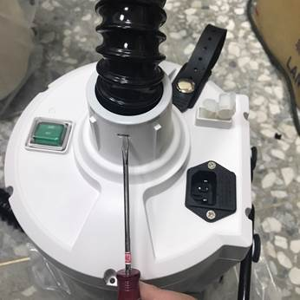 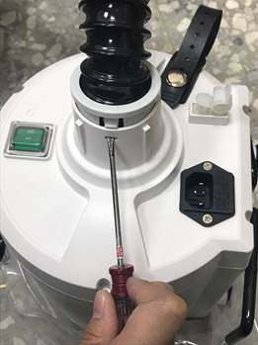

**16-2. Changing filter**

1. Identify the filter cover on the pump bottom.

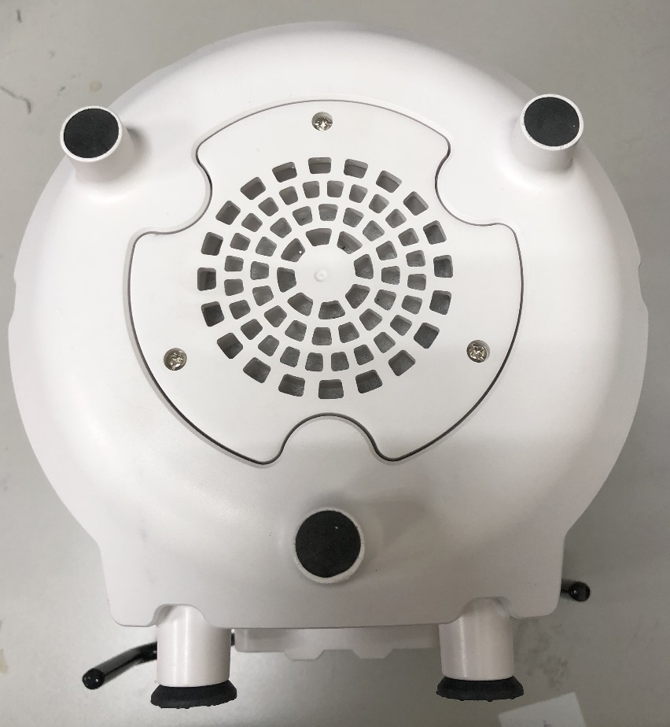

1. Remove 3 screws on the filter cover.

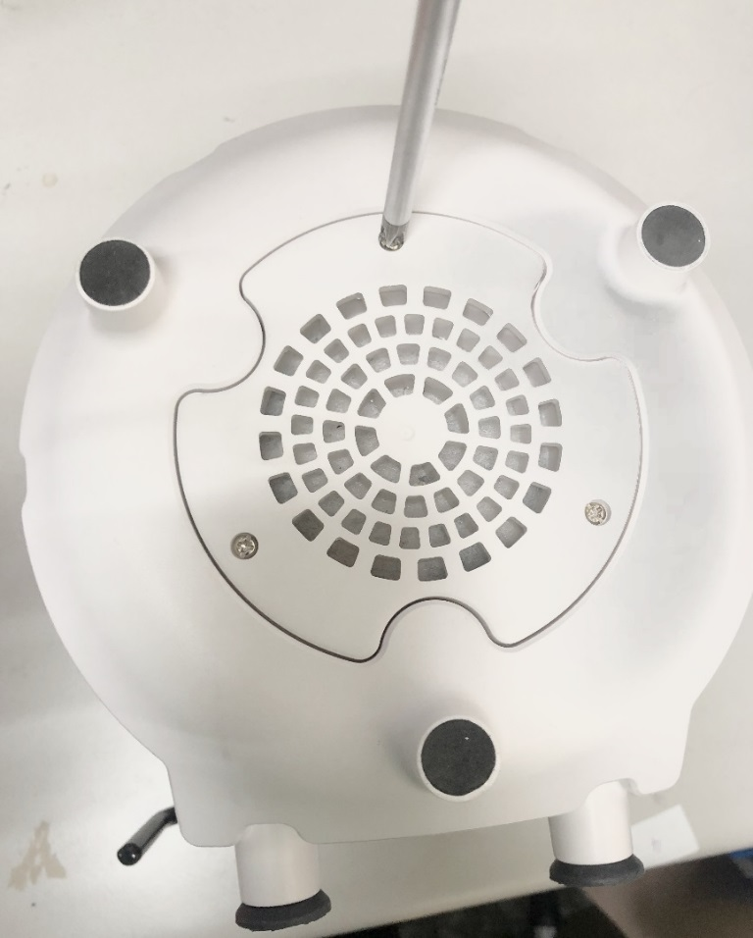

1. Replace the filter inside and assemble the part back in reverse order.

